LAB TEST1 CBES

Sarthak Gupta 21104001

B14

Q)

**CODE:**

const express=require("express")

const app=express()

app.use(express.urlencoded({extended:true}))

app.use(express.json())

const port=8080

const fs=require("fs")

let data=fs.readFileSync("tasks.json","utf-8")

data=JSON.parse(data)

tasks=data["tasks"]

console.log(tasks)

let count=3

app.get("/",(req,res)=>{

res.send("Hey There!")

})

//read all tasks

app.get("/tasks",(req,res)=>{

res.send(tasks)

})

//read task id

app.get("/tasks/:id/",(req,res)=>{

let id=req.params.id

console.log(id)

tasks=tasks.filter((e)=>{

return e.id==id

})

res.send(tasks)

})

//create

app.post("/tasks/",(req,res)=>{

let body=req.body

count++

let n={

"id":count,

"title":body.title,

"description":body.description,

"status":body.status,

"due_date":body.due_date

}

tasks.push(n)

res.send(tasks)

})

//update with id

app.put("/tasks/:id/",(req,res)=>{

let id=req.params.id

let body=req.body

for(let i=0; i<tasks.length;i++)

{

if(tasks[i].id==id)

{

tasks[i].title=body.title

tasks[i].description=body.description

tasks[i].status=body.status

tasks[i].due_date=body.due_date

break

}

}

res.send(tasks)

})

//delete

app.delete("/tasks/:id",(req,res)=>{

let id=req.params.id

tasks=tasks.filter((e)=>{

return e.id!=id

})

res.send(tasks)

})

//Error Handling if req url is wrong

app.use((req,res)=>{

res.send("ERROR : request not found")

})

app.listen(port,()=>{

console.log("server listens at port:" + port)

})

**OUTPUT Screenshot:**

**1)POST**

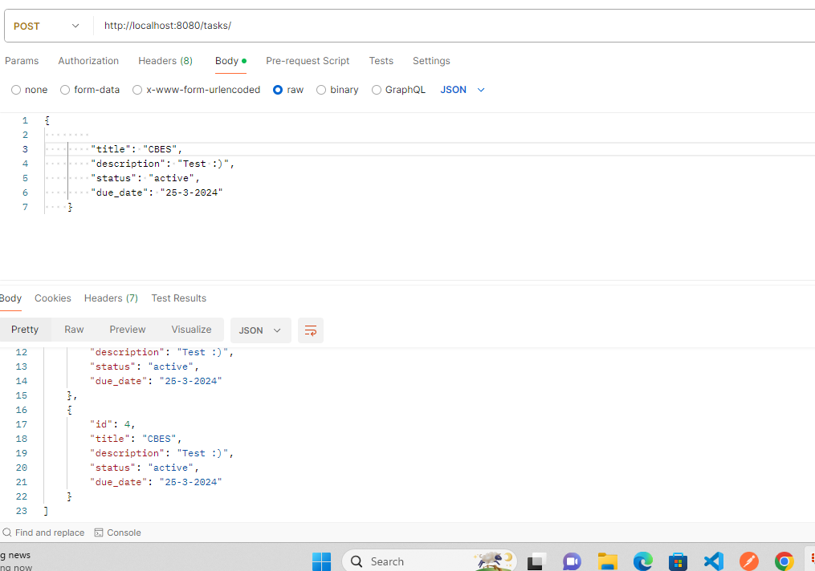

**2)READ**

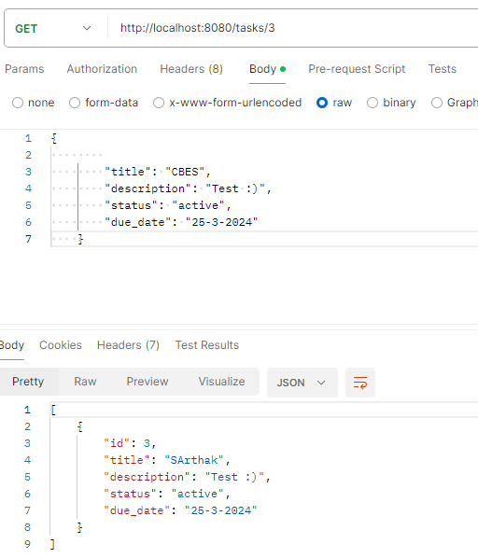

**3)UPDATE:**

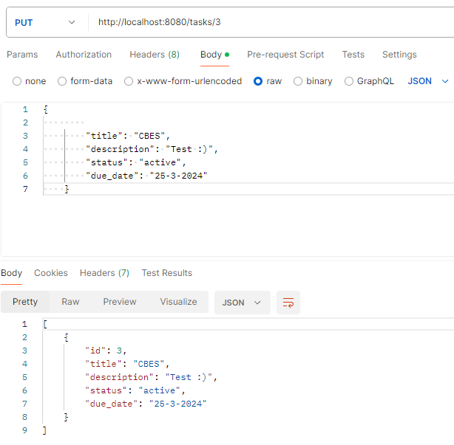

**4) DELETE**

